1. Query: Total Sales Per Product Category Find the total revenue generated for each product category

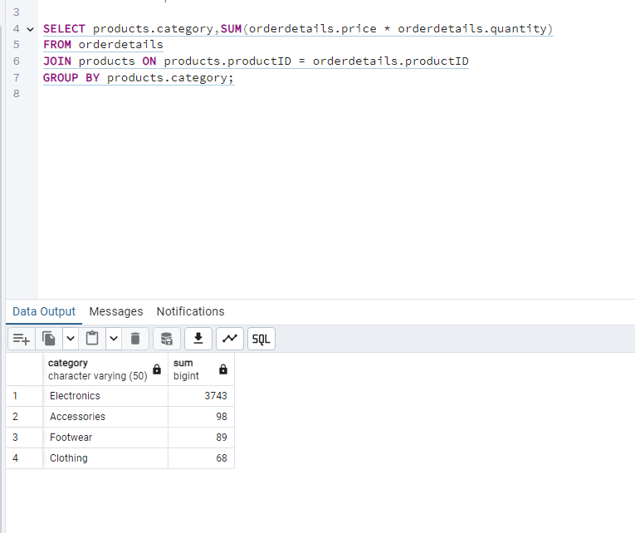

2. Query: Top 5 Customers by Total Spending Identify the top 5 customers who have spent the most on delivered orders.

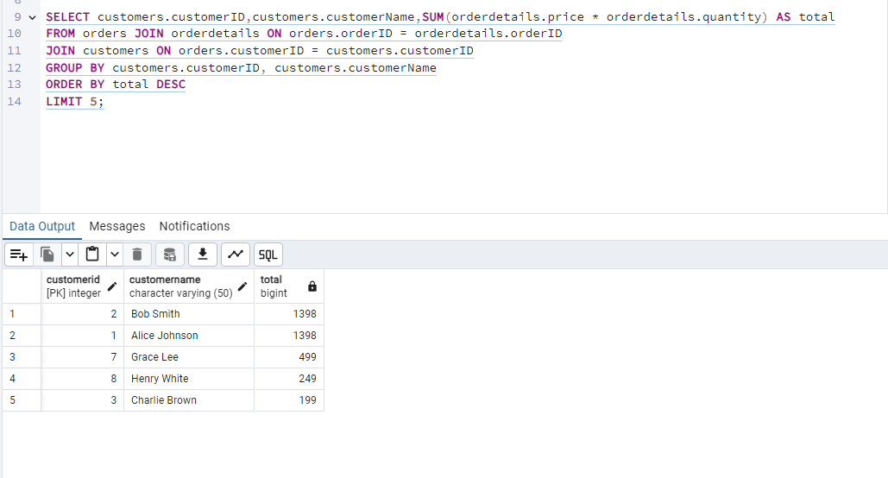
Compute the month-over-month sales growth percentage.

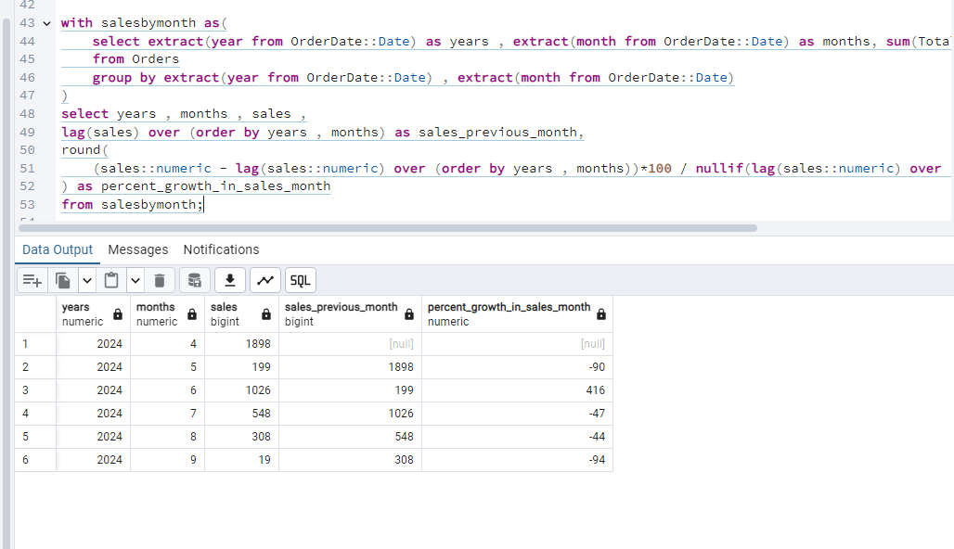
Find the average amount spent per order by each customer.

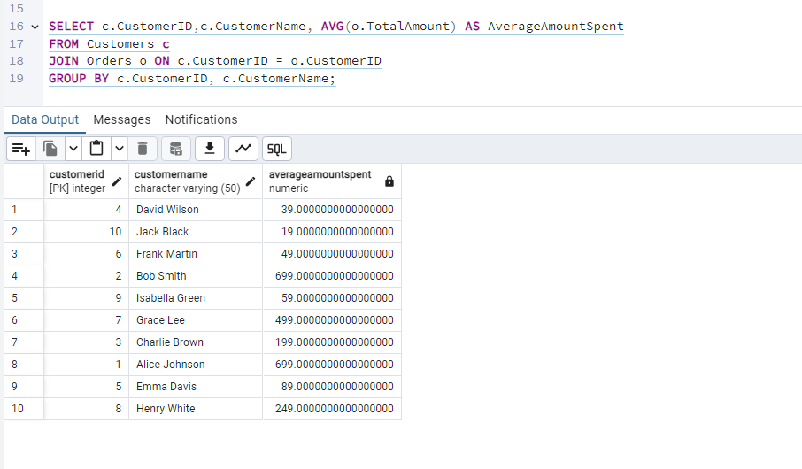
Identify products where the stock quantity is below a given threshold

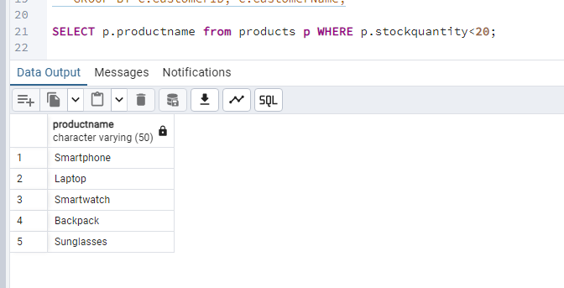
Find the top 10 most frequently ordered products.

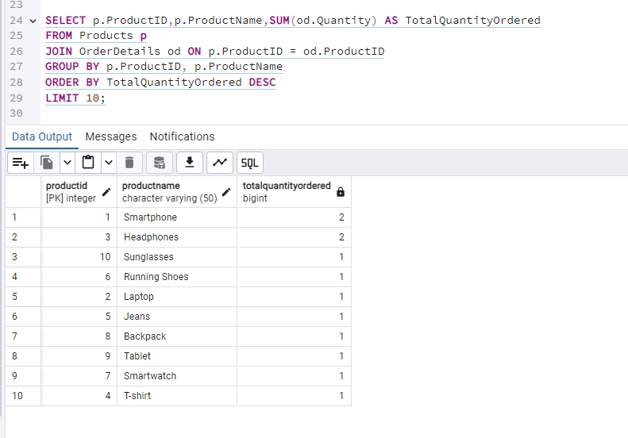
Calculate the percentage of customers who placed another order within 90 days of their first order

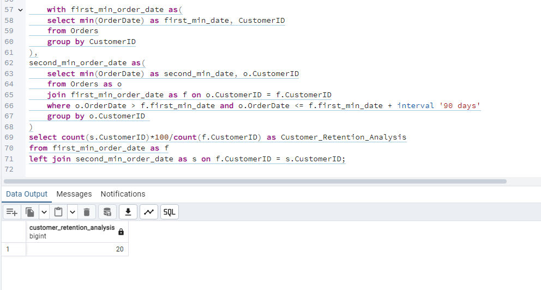

Determine the percentage of total revenue generated by each payment method.
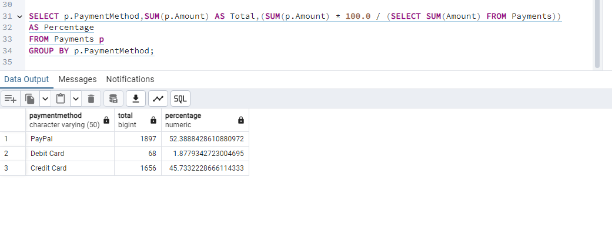
Find the average time taken for an order to move from ‘Pending’ to ‘Delivered’ status.

Calculate the percentage of customers who have made more than one purchase

